Ideation Phase
Define the Problem Statements

Date
Team ID
Project Name | Housing Market Trends: Analysis of Sales Price and Features Using Tableau
Maximum Marks | 2 Marks

Customer Problem Statement Template:
Problem  Statement (PS) | I am  (Customer) | I’m trying to | But | Because | Which makes me feel
PS-1 | A home buyer | understand housing price trends across different locations | it is difficult to compare prices and features | housing data is scattered and not visually represented | confused and unsure about making the right purchase decision
PS-2 | A real estate investor / analyst | analyze how property features affect sales prices | I cannot easily identify patterns and correlations | traditional reports and spreadsheets lack interactive insights | uncertain and less confident about investment decisions.
Home buyers, real estate investors, property analysts, and real estate agents.
A well-articulated customer problem statement allows you and your team to find the ideal solution for the challenges your customers face. Throughout the process, you’ll also be able to empathize with your customers, which helps you better understand how they perceive your product 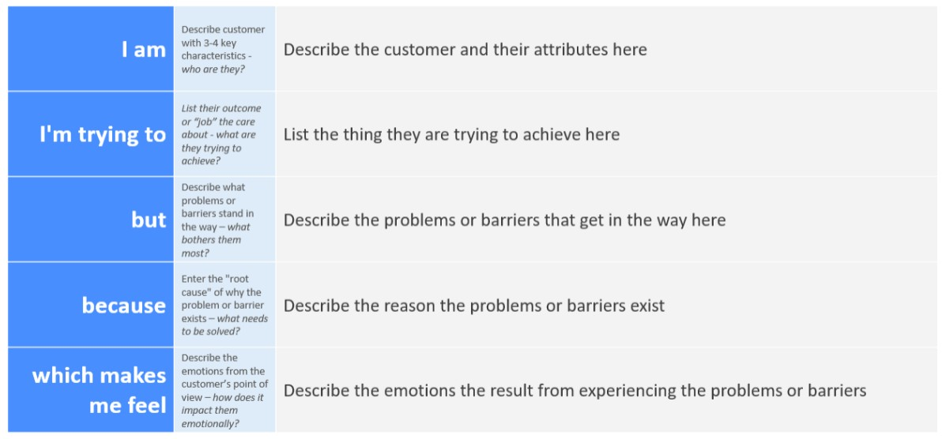or service.

Example:


